SECTION N - PHOTOGRAPHY - YP SHOW ASSOCIATION PHOTOGRAPHY

Colour Prints, Black & White Prints, Skilled Photography, Junior

Convener: Mr Merv Simmonds, Ph: 0438 377 380
Stewards: Copper Coast Photography Club

ENTRY FEE: 50c JUNIOR SECTION:- FREE ENTRY

PRIZE MONEY: 1st $3.00 2nd $2.00 3rd Card only

*Prizes deemed forfeited if not collected by Tuesday following the Show.

Photos must be included with entry form.
Entries close Thursday 10th Aug 2023
Submit to Secretary Kadina Showgrounds, or Post to PO Box 313 Kadina SA 5554

Entries to be judged prior to Show.

Please note
RULES: if photos do not follow the rules:
-they will not be entered for judging or displayed on Show Day.

*A limit of 3 entries per class per entrant.
*All entries must be taken by exhibitor and not have been shown at previous
Kadina Shows.

*ALL photos must be 5”x 7” in size

**NO card is to be mounted on the back of each photo.
*Please label each photo on the back with a sticker that includes entrants name,
address, contact number, class number and detail

*ALL photos must be free of a border or any other distinguishing feature to ensure
judging is equal.

N.B. All exhibits handled with care but no responsibility will be accepted for damage
or loss of entries.

* Exhibitors please ensure your name & address is printed clearly on back of entry.

Exhibits to be picked up on Sunday at 3.30pm or per arrangement with Convener.

PRIZE MONEY: to be signed for & collected at the show office from 4pm onwards.

WINNERS for Best Overall Prizes and Aggregate Points prizes for each
section to be collected from Trophy location within the Exhibition Building.

COLOUR PRINTS – ALL AGES
1 Local interest– Y.P. Event/Location
2 Scene– Land/Sea
3 Sunrise /Sunset
4 Animal, Bird, Fish or insect
5 Flora– Any plant related subject
6 People– Adult/s or Child/ren
7 Action– Sport etc
8 Open Creative
9 Drone shot

BLACK & WHITE PRINTS - All ages:
10 People- Adult/s or Chid/ren
11 Scene– Land/Sea
12 Animal, Bird, Fish or insect
13 Flora– any plant related subject

CAMERA & PHOTOSHOP SKILL - ALL AGES
14 Aperture use (Depth of Field)
15 Shutter speed use
16 Macro

TROPHY Aggregate Points - Classes 1-16
Donated by: Copy King

PRIZE for Best Overall - Classes 1 - 16
Donated by: Copy King
JUNIOR – Under 16 years Colour or B&W Check JUNIOR PHOTOGRAPHY X4 Section in show book. Pages 53-61
17 Scene Land or sea
18 Animal, bird, fish or insect
19 Flora– any plant related subject
20 Sunset/Sunrise
21 People– Adult/s or Child/ren
22 Action– including sport
23 Food

TROPHY Aggregate Points - Classes 17-23
Donated by: Copy King

PRIZE for Best Overall - Classes 17 - 23
Donated by: Copy King

YP SHOW ASSOCIATION PHOTOGRAPHY COMPETITION
Competition held between the three shows, with Kadina hosting for 2023/2024 season.
YP Shows Association level: 1ST prize $30 Copy King sponsorship: $100 gift voucher
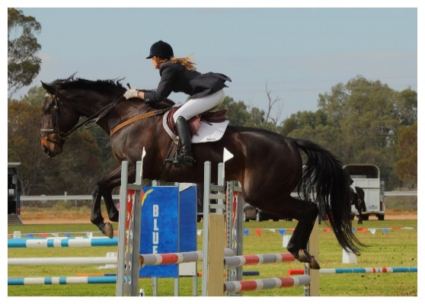 Example only

Photo taken from around Yorke Peninsula, either at any of the 3 shows or district,
mainly to be promoting the YP area.
Size: 8" x 12"
Max Size with border: 10" x 14"
One entry per person
Matte or Border
Minimal manipulation
Commercially processed allowed.
All exhibitors must be an amateur photographer.
All entries must be solely that of the entrant.

Prints may be Black & White or Colour.

More than one entrant must participate for the prizes to be awarded.

No entry can be entered if it has been entered or placed at any YP Show Association show in the previous 2 years

Every care will be taken but no responsibility will be accepted for loss or damage to exhibits."

1ST & only prize:
$30 from YP Shows Association in addition to a $100 gift voucher from COPY KING KADINA

Winner to receive 1st prize
Sponsors:
YP Shows Association: $ 30 to be presented at annual YP Shows Association Presentation Day.
Copy King, Kadina: $100 Gift Voucher

